Backdrop
In this demo, I created a small end-to-end web application using Java 8 and SpringBoot, Angularjs 1(as requirement). I avoided using promise and defer $q for simplicity.
I used Spring Initializer to add all the dependencies and create a blank working project with all my configurations.
I have used Maven as the build tool, though Gradle can also be used. Create spring boot application using https://start.spring.io/.
I have chose SpringBoot because it is easier to configure and plays well with other tech stacks. I have also used a REST API and SpringData JPA with H2 database. Created schema.sql which will create table to store the data(Please be aware that it is test/dev profile and the database is re-create each time. H2 config details defined in application properties.
The application uses server port 9080. So if you want to change please do so in the application property file.
In the UI part, I used AngularJS and BootStrap CSS along with basic JS, CSS, and HTML.
I tried to follow the coding guidelines as much as I could, but all suggestions are welcome.
After saving the todoList details, please login into H2 database to verify the results.

Checkout from Git repository

Git Repository Url to get Code
https://github.com/satishlingutla/todoListDemo.git

1. The main page can be accessed from http://localhost:9080/
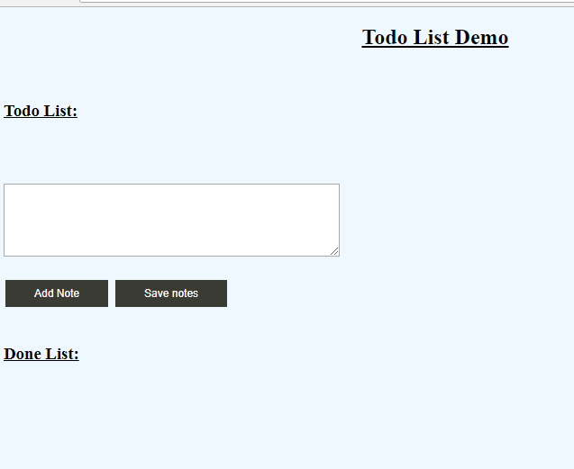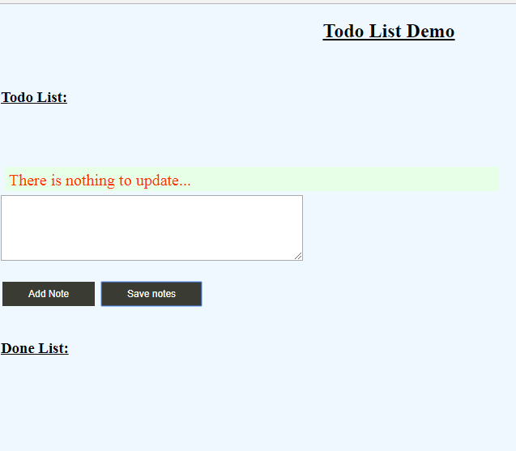

2. 'Add Note' button -- Will add the notes and create an entry under; 'Todo List' item section (Empty notes allowed)
3. Tick the checkbox in ' Todo List'' section then the item will move to ' DoneList' section.
4. Untick the checkbox in 'Don List' Section then the item will move to 'Todo List' section.
5. 'Save Notes' -- button will save all ' Todo List'' and ' Done List'' items to H2 database.
6. There are custom mage error messages

6. Login to H2 mem database and verify the results at
http://localhost:9080/dblogin/
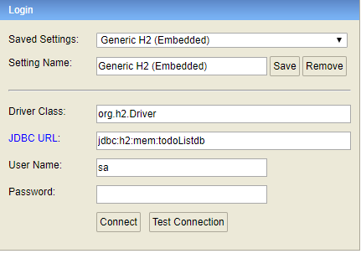
click on 'connect' no password required.

Coding Assumption
==============
1. To speedup coding I did not promise and defer in $http.
2. Only save function created and for other methods prototypes created.
3. I did not use template or dictionary in the demo to simplify the code.
4. Coding done in angular1 because of JD and I have experience in angular 1 and 2.
5. Some error messages displays
6. Protector and Jasmine is not included as part of this project for testing purpose.

